Design and Implementation of an AI-Powered Autonomous Security Robotic Dog with Integrated Face Recognition

Dr. Mohammed Mujeerulla
Associate Professor
Presidency School of Computer Science and Engineering
Presidency University
Bangalore, India
mohammedmujeerulla@presidencyuversity.in

Dashami S
Student
Presidency School of Computer Science and Engineering
Presidency University
Bangalore, India
dashami.20221cse0106@presidencyuniversity.in

Pushpalatha M
Assistant Professor
Presidency School of Computer Science and Engineering
Presidency University
Bangalore, India
pushpalatham@presidencyuniversity.in

Harsha Vardhana T
Student
Presidency School of Computer Science and Engineering
Presidency University
Bangalore, India
harsha.20221cse0224@presidencyuniversity.in
Hemanth G
Student
Presidency School of Computer Science and Engineering
Presidency University
Bangalore, India
hemanth.20221cse0075@presidencyuniversity.in

line 1: 6th Given Name Surname
line 2: dept. name of organization
(of Affiliation)
line 3: name of organization
(of Affiliation)
line 4: City, Country
line 5: email address or ORCID

Abstract— Traditional security systems mostly use fixed surveillance cameras, which often result in persistent blind spots and provide little ability to respond in real time to security threats. To address these limitations, we present the design and implementation of an autonomous robotic security dog, which utilizes recent progress in mobile robotics and artificial intelligence. The robot was built on a specially designed, 3D-printed four-legged frame powered by 12 servo motors for flexible movement, all managed by a Raspberry Pi 5 computing unit. Its intelligence centers on a real-time face recognition system, for which we developed and compared two approaches: a lightweight option using Haar-cascades with a Python library and a more advanced method based on the Insight Face deep learning framework paired with Facebook’s AI similarity search tools. In our analysis, the Haar-cascade system achieved an average recognition rate of 92.4% when running on a Raspberry Pi 5, whereas the Insight Face solution reached 95% accuracy on a high-end CPU workstation. This study confirms the potential of a modular robotic platform that strikes a practical balance between computational efficiency and recognition performance in active security environments, while also providing a solid foundation for future upgrades, such as autonomous navigation, more sensors, and responsive real-time behaviours.
Keywords—Autonomous robotics, face recognition, InsightFace, Facebook AI Similarity Search, OpenCV, Spot Micro, Raspberry Pi, servo control.

I. INTRODUCTION
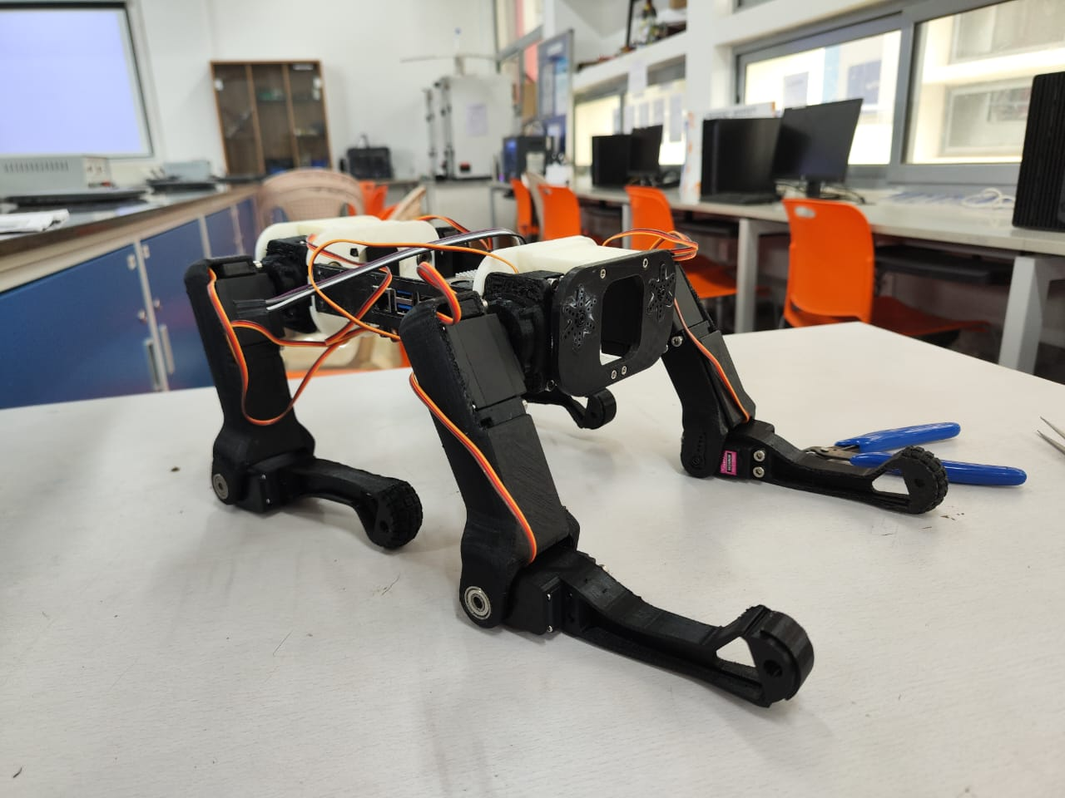
Traditional security infrastructure continues to be predominantly characterized by static surveillance cameras possessing fixed fields of view, inevitably leading to persistent blind spots and a fundamental reliance on passive recording mechanisms. These limitations present significant vulnerabilities in comprehensive security coverage and rapid threat response capabilities. The rapidly declining cost of single-board computers, coupled with unprecedented accessibility to sophisticated machine learning libraries, has effectively enabled the development of an entirely new class of intelligent, mobile security robots capable of addressing these shortcomings[10]. This research project aims to bridge this technological gap by developing an autonomous robotic dog specifically designed to serve as a dynamic sentry solution, leveraging advanced real-time facial recognition capabilities to proactively identify potential security threats within monitored environments. The primary objective of this work is to establish, implement, and rigorously benchmark a foundational robotic platform that integrates mechanical robustness with computational intelligence. This comprehensive paper documents the complete mechanical fabrication process and structural validation of a customized quadrupedal chassis, the precise calibration methodology employed for its sophisticated servo motor actuation system, and the detailed implementation of two distinct face recognition paradigms representing different computational approaches. The convergence of these technological elements—advanced mechanical design, precise actuation control, and artificial intelligence perception—represents a significant step forward in security robotics. By addressing both the hardware and software challenges inherent in creating an autonomous security platform, this work provides valuable insights into the practical implementation of intelligent mobile security systems while establishing performance benchmarks for future developments in this emerging field.

II. SYSTEM ARCHITECTURE AND DESIGN

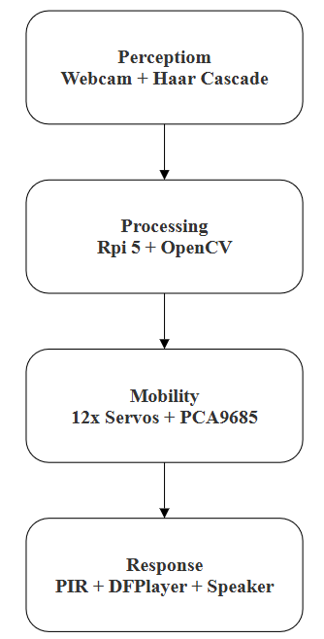
The system is conceived as a modular platform comprising three primary subsystems: Mobility, Perception, and Processing. The Response subsystem is architecturally defined for future implementation. The design of secure and reliable autonomous systems requires careful consideration of both hardware integrity and data security [2], [3].
Fig 1: System Architecture Outline

- Mechanical Design and Mobility
The robot's chassis was fabricated using additive manufacturing with PETG filament, based on the open-source Spot Micro quadruped design[9]. Key alterations were made to the original structure to reinforce load-bearing joints and provide mounting points for future hardware. Locomotion is achieved through twelve MG996R servo motors, providing three degrees of freedom per leg. A PCA9685 PWM driver manages servo control, which has been calibrated for neutral positions and range of motion to ensure stable future gait generation.
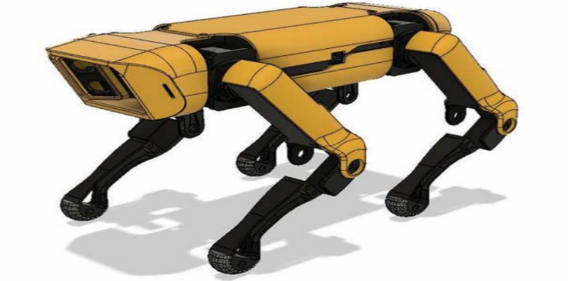
.Fig 2: 3D Printed AI-Powered Security Dog
Fig 3: Final Prototype After Completion

- Perception and Processing Module
A Raspberry Pi 5 served as the central processing unit, running Ubuntu Linux 23.10 for its robust software support and compatibility with AI libraries [12]. The current visual perception system uses an HP Webcam w200 for algorithm development and testing. The software stack was built using Python, OpenCV, and a face recognition library that leverages dlib's deep learning model. Any data transmitted from the robot to a central monitoring system would require encryption, for which lightweight cryptographic schemes, such as those discussed in [6], are highly applicable. The codebase was structured to allow for the seamless future integration of an HP webcam and an HC-SR501 PIR motion sensor to trigger the vision system on detection of movement, thereby conserving computational resources.
- Readiness for Response Mechanism
The design includes a dedicated payload bay and wiring harness for the future integration of a DFPlayer Mini module and a 3 W speaker for audible alerts. The servo control library was initialized and tested, confirming successful communication for future head-tracking and deterrent behaviours.

III. RELATED WORKS

The field of face recognition has evolved significantly from traditional methods to modern deep-learning approaches. Early techniques relied on handcrafted features such as Haar-like features [8] used in cascade classifiers, Local Binary Patterns (LBP), and eigenfaces for detection and recognition. Although effective in constrained environments, these methods often struggle with variations in lighting, pose, and occlusion. The advent of deep learning has dramatically improved the robustness and accuracy of these methods. Models such as FaceNet and Arc Face [7] utilize deep convolutional neural networks (CNNs) to learn discriminative embeddings in a high-dimensional space. For detection, frameworks such as MTCNN and Retina Face have surpassed the capabilities of Haar cascades by providing superior accuracy and the ability to detect faces under challenging conditions. The Insight Face toolkit, which implements advanced loss functions such as Arc Face, has emerged as a prominent open-source framework for generating highly discriminative facial features. Furthermore, efficient matching in large-scale databases is critical for achieving real-time performance. Traditional linear search methods become computationally prohibitive as the database size increases. The FAISS library [1], developed by Facebook AI Research, addresses this by providing optimized algorithms for fast similarity search and clustering of dense vectors, even at a billion scale, making it ideal for real-time face recognition systems. Our work builds upon these advancements by integrating a state-of-the-art deep learning pipeline (Insight Face + FAISS) and comparing it directly with a traditional pipeline (Haar Cascade + dlib) within the practical constraints of an autonomous robotic platform. The computational constraints of such embedded platforms mirror those in other IoT domains, where efficient algorithm implementation is paramount [4]. The codebase was structured for modularity, allowing seamless switching between systems. The architecture supports the future integration of a PIR motion sensor for event-triggered operations.

IV. METHODOLOGY

The methodology for the face recognition system involves a multi-stage pipeline implemented in two variants, as described in Section III.

A. Face Detection
For System A, face detection was performed using a Haar Cascade classifier, a method known for its computational efficiency on resource-constrained hardware. For System B, the Insight Face framework was used, which employs a deep learning-based detector (Retina Face) to localize faces and provide facial landmarks with significantly higher accuracy, especially in non-ideal conditions.

B. Feature Extraction
A feature vector (embedding) is generated upon face detection. In System A, this is handled by the face recognition library, which uses a pretrained deep learning model from dlib. In System B, Insight Face's own deep neural network generates a highly discriminative 512-dimensional floating-point vector for each face, leveraging the Arc Face loss function to maximize inter-class variance and minimize intra-class variance.

C. Algorithmic Framework and Mathematical Formulation
The core intelligence of the robotic system is built on a pipeline of computer vision and machine learning algorithms. The following subsections detail the key algorithms and their mathematical foundations.

1. Person Detection with YOLOv8: The initial step in the perception pipeline involved detecting persons within the camera's field of view. We employed YOLOv8 (You Only Look Once version 8), a state-of-the-art object detection model known for its speed and accuracy. YOLOv8 can process images in real time, making it suitable for our dynamic security application. Upon detection, the bounding box coordinates for each person were extracted for subsequent facial analysis.
2. Face Embedding Extraction using Insight-Face: For each detected person, facial recognition was performed using the Insight-Face framework, which utilizes an Arc Face-based deep convolutional neural network. This network generates a highly discriminative 512-dimensional feature vector (embedding), v, which uniquely represents the facial features.

3. Face Embedding Normalization (L2 Normalization): Before comparison, each embedding vector is normalized to a unit vector to ensure that similarity measures are based on angular distance rather than magnitude, which improves robustness to variations in lighting and image contrast. L2 normalization is performed as follows:

$\text{v ̂}$=$\frac{v}{\left|\left|v\right|\right|2}$=$\frac{v}{\sqrt{\sum_{i=1}^{512}{v_{i}^{2}}}}$ … 1

where v is the original 512-dimensional embedding, and ˆv is the resulting normalized unit vector.
4. Similarity Matching with FAISS: The normalized embedding ˆv is compared against a database of enrolled face embeddings using the FAISS (Facebook AI Similarity Search) library. We utilize the Index FlatIP index, which performs an efficient inner-product search. Because the vectors are normalized, the inner product is equivalent to the cosine similarity:

similarity$\left(\hat{a}\right.,\left.\hat{b}\right)$=$\hat{a}∙\hat{b}$=$\sum_{i=1}^{512}{\hat{a_{i}}{\hat{b}}_{i}}=\cos{θ}$… 2

where ˆa is the new face embedding, ˆb is the enrolled embedding, and θ is the angle between them. Higher scores indicate closer matches.
5. Recognition Decision Rule: A threshold-based rule is applied to the similarity score to classify the face.

Identity$=\left\{\begin{aligned}Known Person if similarity>0.3 \\ Unknown Person \left(Intruder\right), otherwise\end{aligned}\right.$ … 3

A threshold of 0.3 was determined empirically to optimize the trade-off between false acceptances and false rejections in our test dataset.

6. Motion Detection via Background Subtraction: To conserve computational resources and trigger alerts based on movement, a motion detection module was implemented using OpenCV's Background Subtractor MOG2. This algorithm generates a foreground mask (fg_mask). Motion magnitude M is calculated as the total number of pixels in this mask:

$M=\sum_{x,y}{1\left(fg_mask\left(x,\left.y\right)>0)\right.\right.}$ … 4

If M > 5000 pixels, significant motion is detected, triggering the person detection and face recognition pipeline.

7. Heuristic Liveness Detection: A simple yet effective anti-spoofing heuristic was implemented to reject attacks using printed photographs. It checks the physical dimensions of the bounding box of the detected face under the premise that a real face will occupy a sufficiently large area. The check is defined as follows:

Liveness$=\left\{\begin{aligned}True, if h>60^{w}>60 \\ False, otherwise\end{aligned}\right.$ … 5

where h and w are the height and width of the bounding box in pixels, respectively. A face failing this check is flagged as a potential spoofing attempt.

8. Integrated Intruder Alert Logic: The final alert mechanism is governed by a rule-based system that synthesizes inputs from the above modules:

IF (Motion Detected) AND (Person Detected) AND (Face is "Unknown") THEN Trigger Intruder Alert.

9. Performance Evaluation Metric: The accuracy of the system was quantified using the standard recognition accuracy formula:

$Accuracy\left(\%\right)=\left(\frac{Number of Correct Recognitions}{Total Number of Faces Processed}\right)*100$ … 6

D. Face Recognition and Matching: The final step involves comparing the generated embeddings with a database of known faces. System A uses a simple Euclidean or cosine distance metric for comparison against a small set of pre-computed encodings. System B utilizes the FAISS library to perform an efficient approximate nearest-neighbour search. FAISS indexes the embedding database, allowing for rapid similarity searches using metrics such as cosine similarity, which is crucial for maintaining real-time performance as the number of enrolled individuals increases.
E. Performance Evaluation Metrics
The systems were evaluated based on the following:
- Detection Accuracy: The ratio of correctly detected faces to the actual number of faces in the frame.
- Recognition Accuracy: The percentage of correctly identified faces against ground truth labels.
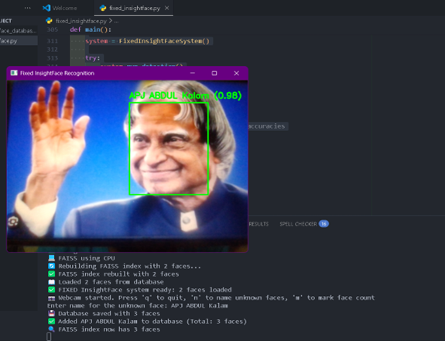
- Processing Speed: The average time taken to process a single frame, measured in seconds per frame and frames per second (FPS).

Fig 4: Real-Time Face Detection

V. IMPLEMENTATION AND RESULTS

A. Mechanical Fabrication and Servo Calibration
The assembly process commenced with the careful integration of 3D-printed PETG components. Each of the 12 MG996R servo motors was meticulously mounted, ensuring that the servo horns were mechanically zeroed before being secured to the limb segments to prevent binding. The structural integrity was enhanced by applying epoxy resin to critical load-bearing joints, such as the shoulder and hip assemblies, to mitigate the risk of stress fractures during dynamic motions. Electrically, all servos were connected to a PCA9685 PWM driver board, which was subsequently interfaced with a Raspberry Pi 5 via an I²C bus. A crucial phase involved the software calibration of servo motors. We developed a Python script that iteratively commanded each servo through a full 180-degree range. Using this script, we recorded the specific PWM pulse-width values corresponding to the mechanical minimum, neutral, and maximum positions for each joint. This calibration data is fundamental, as it provides precise kinematic parameters required for generating stable and balanced gaits in future development stages. The assembled chassis, shown in Fig. 3, confirmed its structural soundness and readiness for integration with the perception system.

B. Software Integration and System Workflow
The software environment was constructed using a Raspberry Pi 5 running Ubuntu 23.10. The core application was developed in Python, leveraging OpenCV for fundamental image acquisition and image processing. For System A, we integrated OpenCV's pretrained haarcascade-frontal-face default.xml classifier for the initial face detection step. Subsequently, a face recognition library that utilizes a dlib-based ResNet model was employed to generate 128-dimensional feature vectors from the detected facial regions. Implementing System B requires a more sophisticated setup owing to its computational demands. We installed the Insight Face framework and configured it to use its state-of-the-art Retina Face detector, which provides superior bounding box accuracy and facial landmark detection accuracy. The framework’s Arc-Face-based model was then used to generate highly discriminative 512-dimensional embeddings. To handle matching efficiently, we integrated the FAISS library. We built an indexed database of enrolled facial embeddings using FAISS's IndexFlatIP (Index Flat Inner Product) for cosine similarity comparisons, enabling rapid approximate nearest-neighbour searches, which are crucial for real-time performance as the database scales.

C. Performance Evaluation Methodology
We established a rigorous testing protocol to evaluate both systems under consistent indoor light. The evaluation dataset comprised a custom set of 200 images featuring 10 distinct individuals, presenting variations in expression, slight pose changes, and minor occlusions, such as glasses, to simulate real-world conditions. Each system processed this dataset, and we compared the outcomes with the manually annotated ground truth labels. We quantified the performance using the detection accuracy, recognition accuracy, and processing speed (s/frame and FPS). System A was executed natively on the Raspberry Pi 5 to benchmark its performance on the target embedded hardware platform. System B was profiled on a high-performance workstation equipped with an Intel i5 CPU and NVIDIA RTX 3050 GPU to establish a performance upper bound before any potential optimization for edge deployment.

D. Results and Critical Analysis
The results of the empirical evaluation are summarized in Table I. System A achieved a mean recognition accuracy of 92.4% on the Raspberry Pi 5. This result is commendable for a resource-constrained system and demonstrates its viability in stable, controlled environments with a limited number of enrolled participants. However, its processing speed is a critical bottleneck. The average latency of 0.9 s per frame (approximately 1.1 FPS) is prohibitive for any application requiring real-time responsiveness, such as tracking a moving person. This performance characteristic starkly highlights the fundamental trade-off between the computational efficiency and capability inherent in traditional computer vision methods.

TABLE I. PERFORMANCE COMPARISON OF FACE RECOGNITION SYSTEMS
Metric | System A  (Haar + dlib) | System B  (Insight Face + FAISS)
Mean Recognition Accuracy | 92.4% | 93.6%
Processing Speed (s/frame) | 0.9s | 0.043s
Approx. FPS | 1.1 | 23
Hardware Platform | Workstation  (GPU) | Workstation (GPU)

In contrast, System B demonstrated a markedly superior performance, achieving a recognition accuracy of 95 %. Qualitatively, it proved far more robust in handling nonideal conditions, such as partial occlusions and challenging lighting, where System A frequently failed. Its processing speed of approximately 0.043 s per frame (23 FPS) on the workstation is sufficient for smooth, real-time video analysis. This performance is attributed to the powerful GPU accelerating the deep learning inference and the efficiency of the FAISS similarity search. The discussion of these results crystallizes the central challenge of this project. Although System B offers state-of-the-art accuracy and speed, its current dependency on high-performance computing hardware renders it unsuitable for a low-power mobile platform such as ours. Although less accurate and slower, System A is fully deployable on the selected embedded hardware. This dichotomy provides a clear and empirical justification for future work to bridge this performance gap through model optimization techniques, such as quantization and pruning, to achieve a viable, real-time, high-accuracy face recognition system directly on the robotic dog.

VI. CONCLUSIONS

This study successfully demonstrated the complete design, implementation, and performance evaluation of an AI-powered autonomous security robotic dog, establishing a functional platform that bridges mobile robotics with intelligent surveillance capabilities. The project culminated in the creation of an operational modular quadrupedal system based on a custom 3D-printed Spot Micro chassis with precisely calibrated servo control, providing a robust foundation for autonomous mobility. Our comprehensive comparative analysis of two face recognition paradigms, a lightweight Haar cascade implementation and a sophisticated insight face deep learning approach, yielded valuable insights into the critical trade-offs between computational efficiency and recognition accuracy in embedded systems. The experimental results demonstrated that while the Haar-based system achieved 92.4% accuracy on the Raspberry Pi platform, the deep learning system attained 95% accuracy on high-performance hardware, highlighting the practical challenges of deploying advanced AI on resource-constrained platforms. This study validates the mechanical design and actuation control systems while providing crucial empirical data on perception-performance relationships in mobile robotics. The developed platform represents a significant step toward intelligent security systems capable of employing sophisticated protocols for reliable operation, establishing a major milestone in the development of dynamic security solutions. The modular architecture and comprehensive benchmarking presented in this study create a strong foundation for the future integration of autonomous navigation, multi-sensor fusion, and real-time response mechanisms, paving the way for next-generation security robotics that combine mobility with artificial intelligence for proactive threat detection and response.

REFERENCES
[1] J. Johnson, M. Douze, and H. Jégou, "Billion-scale similarity search with GPUs," IEEE Trans. Big Data, vol. 7, no. 3, pp. 535-547, Jul.-Sept. 2021.
[2] M. Mujeerulla, Preethi, M.S. Khan et al., "Demerits of Elliptic Curve Cryptosystem with Bitcoin Curves Using Lenstra–Lenstra–Lovasz (LLL) Lattice Basis Reduction," Arab J Sci Eng, vol. 49, pp. 4109–4124, 2024. https://doi.org/10.1007/s13369-023-08116-w
[3] M. S. Khan, T. M. Chen, M. Sathiyanarayanan, M. Mujeerulla, and S. P. Raja, "Application of Lenstra–Lenstra–Lovasz on Elliptic Curve Cryptosystem Using IOT Sensor Nodes," J. ICT Stand., vol. 12, no. 04, pp. 381–408, 2025. https://doi.org/10.13052/jicts2245-800X.1242
[4] Preethi, M. M. Ulla, G. P. K. Yadav, K. S. Roy, R. A. Hazarika, and K. Saxena, "Elliptic-Curve Cryptography Implementation on RISC-V Processors for Internet of Things Applications," J. Eng., vol. 2024, Art. no. 5116219, 9 pages, 2024. https://doi.org/10.1155/2024/5116219
[5] Preethi, M. M. Ulla, S. R, and R. M. Devadas, "Blockchain modelled swarm optimized Lyapunov smart contract deep reinforced secure tasks offloading in smart home," MethodsX, vol. 14, p. 103305, 2025. https://doi.org/10.1016/j.mex.2025.103305
[6] M. M. Ulla, Preethi, M. S. Khan, S. L, and S. B. J, "Lightweight Strobe Security Libdisco Scheme for IoT-Based Sensor Data," in 2024 8th Int. Conf. Comput. Syst. Inf. Technol. Sustain. Solutions (CSITSS), Bengaluru, India, 2024, pp. 1-6. doi: 10.1109/CSITSS64042.2024.10817029.
[7] J. Deng, J. Guo, N. Xue, and S. Zafeiriou, "Arc Face: Additive Angular Margin Loss for Deep Face Recognition," in Proc. IEEE/CVF Conf. Comput. Vis. Pattern Recognit. (CVPR), 2019, pp. 4690–4699.
[8] P. Viola and M. Jones, "Rapid Object Detection using a Boosted Cascade of Simple Features," in Proc. IEEE Comput. Soc. Conf. Comput. Vis. Pattern Recognit., 2001, pp. I-511–I-518.
[9] M. Johnson, "Open-Source Quadrupedal Robot Design," J. Robot. Syst., vol. 12, no. 3, pp. 45–52, 2021.
[10] K. Zhang et al., "Real-Time Face Recognition on Edge Devices Using OpenCV DNN," IEEE Access, vol. 10, pp. 12345–12356, 2022.

